**Instagram user analytics**

**Project Description**

This project focuses on analysing Instagram user interactions and engagement using MySQL Workbench. The goal is to extract meaningful insights that support the product and marketing teams in making informed decisions about user retention, campaign strategies, and platform improvements.

**Approach**

1. Explored the database structure, including tables like users, photos, likes, tags, photo_tags, comments, and follows.
2. Created SQL queries to answer the given tasks.
3. Analysed outputs to derive actionable insights as asked.
4. Compiled queries, outputs, and conclusions in a structured report.

**Tech-Stack Used**

1. **MySQL Workbench:** Used for writing and executing SQL queries.
2. **SQL:** Structured Query Language for data extraction and analysis.

**Queries and Outputs**

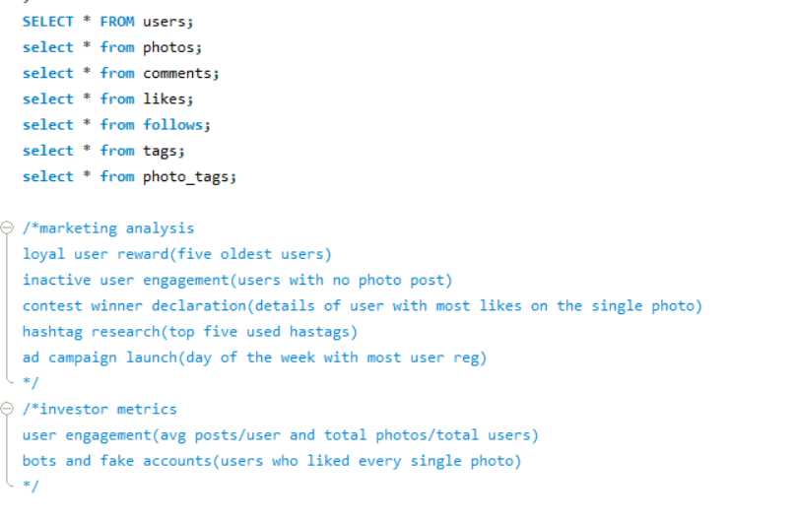

Marketing analysis:

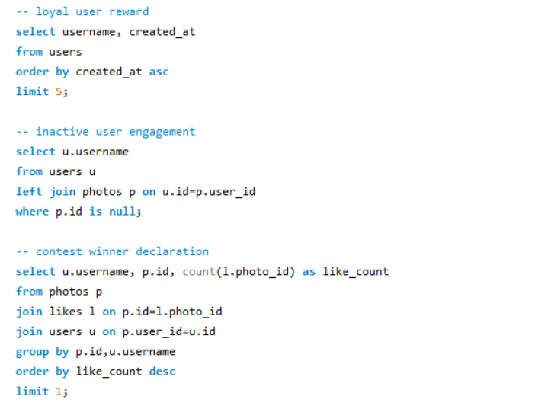

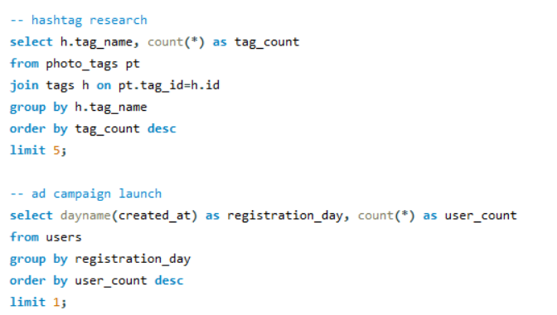

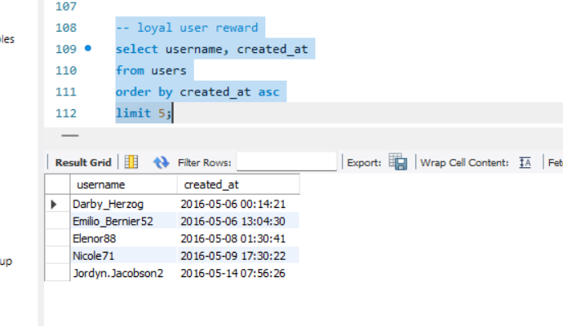

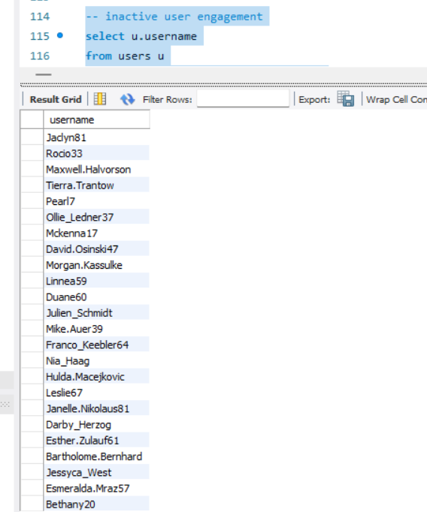

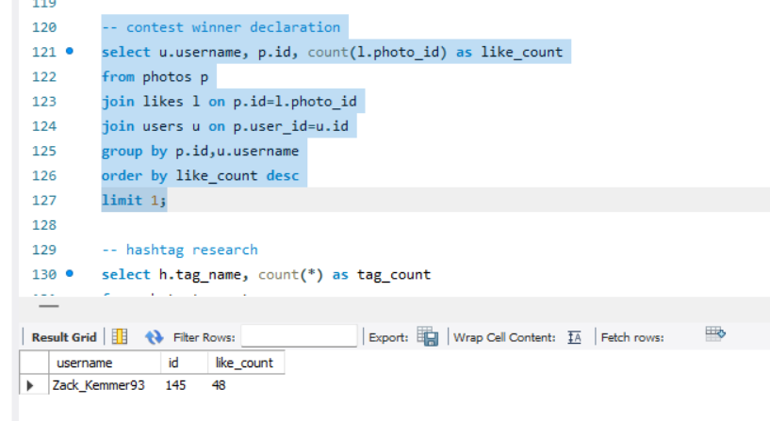

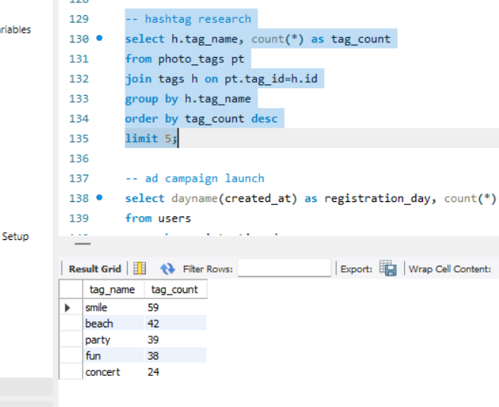

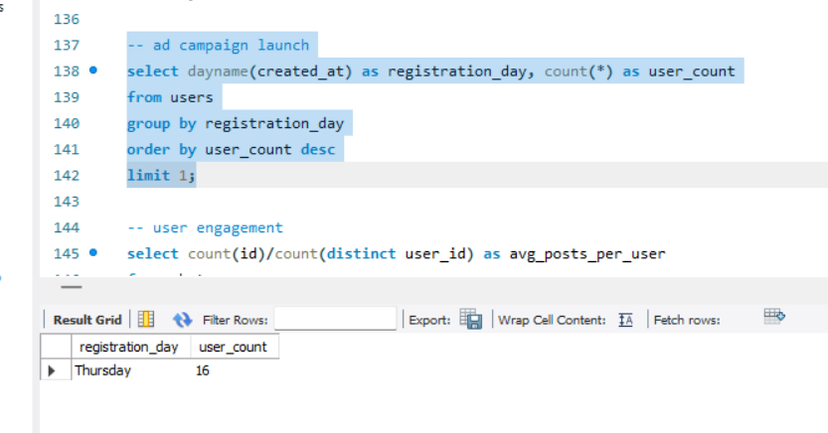

Investor metrics:

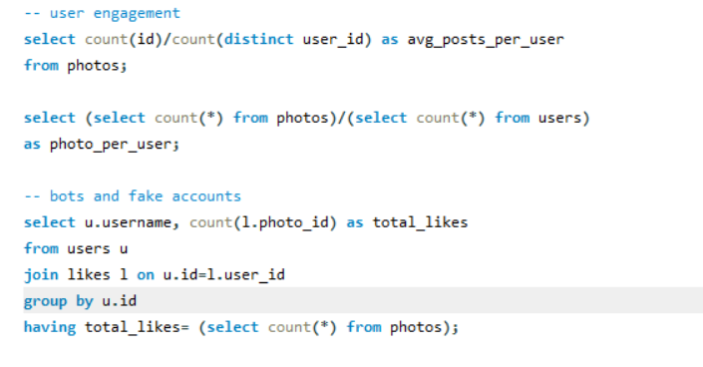

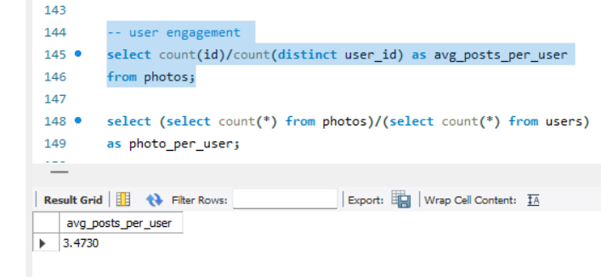

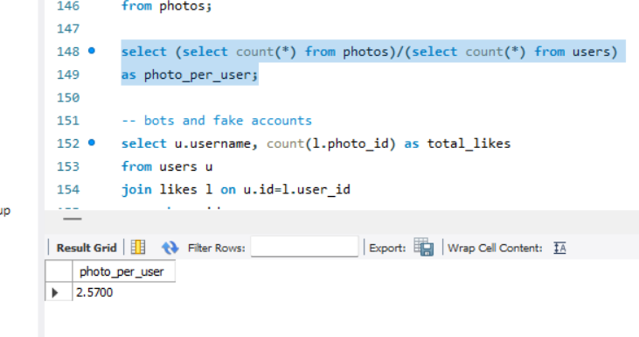

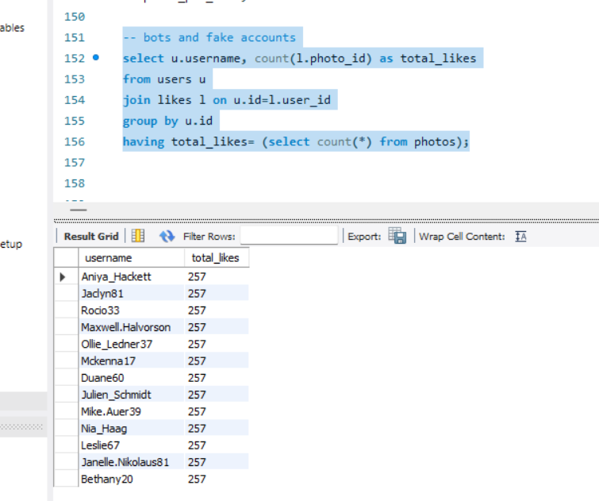

**Insights**

1. Most loyal users can be approached for rewards or brand ambassador opportunities.
2. For inactive users, targeted email campaigns should be made to encourage them to share their first post.
3. Promoting the content of contest winner for user with most likes on a single photo can inspire others to participate in similar contest.
4. Hashtag research helps partner brands align their marketing strategies.
5. Ad campaign launch analytics could help team schedule ads and running those in high-traffic days.
6. User engagement helps in taking actions regarding feature improvements and content incentives.
7. Bot accounts detection helps in tacking fake accounts, helping authentic engagement and platform integrity.

**Results**

1. Successfully identified key user behaviours.
2. Provided actionable insights for marketing and product teams.
3. Highlighted areas of concern for investor reporting.